FACULTY PROFILE

Name of the Faculty |  | : |  | Dr. C. SRINIVASA KUMAR |  |  |  |  |  |  | 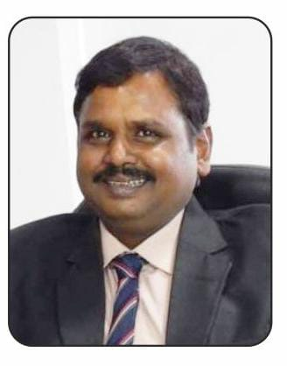
Designation |  | : |  | Professor and Head,
Department |  | : |  | CSE (DATA SCIENCE)
JNTUH Reg. ID |  | : |  | 4929-150409-144539
Date of Birth |  | : |  | 12-06-1972
Date of Joining |  | : |  | 05-05-2020
Memberships |  | : |  | LM-ISTE, IAENG, SDIWC, IJIEMR-ELSEVIER ,APSMS
Mobile |  | : |  | 9849715531 |  |  |  |  | Mail: |  |  | drcskumar46@gmail.com
Academic Qualifications:
S.No | Degree |  |  |  | College/University |  |  | Year of Passing |  |  |  |  |  | % of Marks
1 | Ph.D |  |  |  | GITAM University |  |  | 2013 |  |  |  |  |  | Awarded
2 | M.Tech |  |  |  | AAIDU |  |  | 2006 |  |  |  |  |  | 78.5
3 | M.Sc. |  |  |  | S.V. University |  |  | 1994 |  |  |  |  |  | 74.2
Teaching/Industry Experience:
S.No | Name of the Organization |  |  |  |  | Designation |  | From |  |  | To |  |  | Year & Months
1 | Vignan Institute of Management and Technology for Women, Hyd. |  |  |  |  | Professor (Ratified by JNTUH) & Head |  | 05-05-2020 |  |  | Till date |  |  | 5.2
2 | Vignan Institute of Technology and Science,Hyd |  |  |  |  | Professor/Head/Principal |  | 20-02-2013 |  |  | 04-04-2020 |  |  | 7.1
3 | Gopal Reddy College of Engg. & Tech.,Hyd |  |  |  |  | Professor/Principal  (Ratified) |  | 02-02-2009 |  |  | 19-02-2013 |  |  | 4.0
4 | RRS College of Egg. & Tech.,Hyd. |  |  |  |  | Professor & Head |  | 02-06-2008 |  |  | 31-01-2009 |  |  | 0.8
5 | Jaya Mukhi Institute of Technological Sciences, Warangal |  |  |  |  | Professor and Director for MCA |  | 21-10-2007 |  |  | 01-06-2008 |  |  | 0.7
6 | Vignan’s Engineering College, Vadlamudi |  |  |  |  | Associate Professor |  | 09-11-2000 |  |  | 20-10-2007 |  |  | 6.11
7 | Vaagdevi College of Engineering, Warangal. |  |  |  |  | Assistant Professor |  | 03-08-1998 |  |  | 04-11-2000 |  |  | 2.2
8 | S V University, Tirupati |  |  |  |  | Teaching Assistant |  | 23-06-1996 |  |  | 02-08-1998 |  |  | 2.1
9 | Vaagdevi Degree & P.G. College, Warangal. |  |  |  |  | Lecturer |  | 12-10-1994 |  |  | 22-06-1996 |  |  | 1.11
Research Publications:
No. of Papers |  |  | International |  |  | : | 76 | National |  | : |  |  | 12
No. of Conference |  |  | International |  |  | : | 9 | National |  | : |  |  | -
No. of Patent |  |  | International |  |  | : | - | National |  | : |  |  | 6
No. of Books |  |  | International |  |  | : | - | National |  | : |  |  | 7
No. of FDPs |  |  | Attended |  |  | : | 7 | Conducted |  | : |  |  | 2
No. of Workshops/Seminars |  |  | Attended |  |  | : | 12 | Conducted |  | : |  |  | 12
Date of Ratification |  |  | 05-05-2023 |  |  | Designation |  | Professor

