FACULTY PROFILE

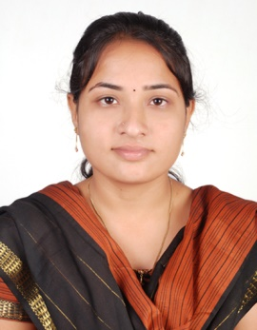Name of the Faculty **:** Mrs.P.Amareshwari Designation **:** Assistant Professor

Department **:** CSE(DS)

JNTUH Reg. ID **:** 0553-191108-150824

Date of Birth **:** 25-02-1992

Date of Joining **:** 16-02-2024

Memberships **:** IAENG,IFERP

Mobile **:** 8125107502 Mail:amareshwari.parunandi@gmail.com

|  |  |  |  |  |  |  |  |  |  |  |  |  |
| --- | --- | --- | --- | --- | --- | --- | --- | --- | --- | --- | --- | --- |
| **Academic Qualifications:** | | | | | | | | | | | | |
| S.No. | Degree | | College/University | | | | | Year of Passing | | % of Marks | | |
| 1 | B.Tech | | PRRM Engineering college | | | | | 2013 | | 73% | | |
| 2 | M.Tech | | JBIET Engineering college | | | | | 2016 | | 86% | | |
| **Teaching/Industry Experience:** | | | | | | | | | | | | |
| S.No. | Name of the Organization | | | Designation | | From | | | To | Year & Months | | |
| 1 | VMTW, Hyderabad | | | Assistant Professor | | 2024 | | | till date |  | | |
| 2 | Neil Gogte Institute Of Technology | | | Assistant Professor | | 2021 | | | 2024 | 3 Years | | |
| 3 | Holy Mary Institute Of Technology And Science | | | Assistant Professor | | 2019 | | | 2021 | 2 Years | | |
| 4 | Globallogic Technologies | | | Senior Analyst | | 2015 | | | 2018 | 3 Years | | |
| 5 | Bhargav Solutions | | | Web Developer | | 2013 | | | 2014 | 1 Years | | |
| **Research Publications:** | | | | | | | | | | | | |
| No. of Papers | | International | | **:** | 4 | | National | | | | **:** | 0 |
| No. of Conference | | International | | **:** | - | | National | | | | **:** | 0 |
| No. of Patent | | International | | **:** | - | | National | | | | **:** | - |
| No. of Books | | International | | **:** | - | | National | | | | **:** | - |
| No. of FDPs | | Attended | | **:** | 3 | | Conducted | | | | **:** | - |
| No. of Workshops/Seminars | | Attended | | **:** | 2 | | Conducted | | | | **:** | - |
| **Ratification: Assistant Proffesor** | | | | | | | | | | | | |