FACULTY PROFILE

Name of the Faculty |  |  | : | Mrs.B.Sangeetha |  |  |  |  |  |  |  |  |  |  | 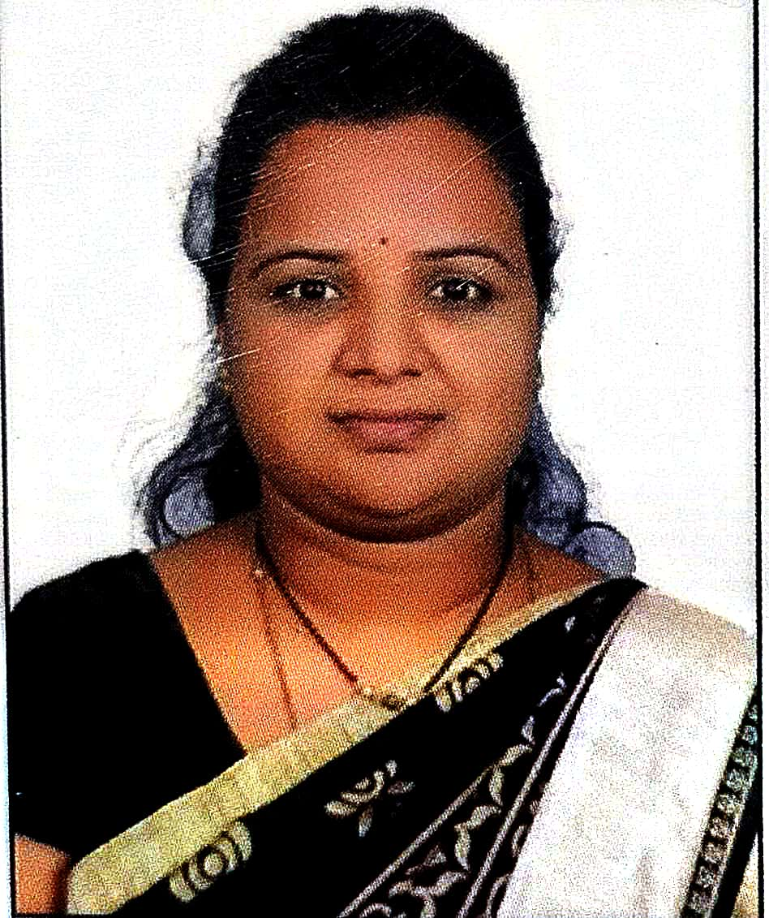
Designation |  |  | : | Assistant Professor
Department |  |  | : | CSE(Data Science)
JNTUH Reg. ID |  |  | : | 9848-230415-120030
Date of Birth |  |  | : | 31/07/1991
Date of Joining |  |  | : | 14/4/2023
Memberships |  |  | : | 2
Mobile |  |  | : | 9160933616 |  |  |  |  |  |  | Mail |  | :
Academic Qualifications:
S.No. | Degree |  |  |  | College/University |  |  |  |  | Year of Passing |  |  |  |  |  | % of Marks
1 | SSC |  |  |  | SGVM High School |  |  |  |  | 2004 |  |  |  |  |  | 78
2 | Diploma |  |  |  | KNPW |  |  |  |  | 2007 |  |  |  |  |  | 75
3 | B.E |  |  |  | MVSR Engineering College |  |  |  |  | 2010 |  |  |  |  |  | 70
4 | M.Tech |  |  |  | BIET |  |  |  |  | 2013 |  |  |  |  |  | 88
Teaching/Industry Experience:
S.No. | Name of the Organization |  |  |  |  | Designation |  | From |  |  |  | To |  |  |  | Year & Months
1 | VMTW, Hyderabad |  |  |  |  | Asst. Professor |  | 14/4/2023 |  |  |  | Till date |  |  |  | 2 year
2 | Valuelabs LLP |  |  |  |  | Data Analyst |  | 17/5/2013 |  |  |  | 14/8/2022 |  |  |  | 9 years
3 | KNPW |  |  |  |  | Professor |  | 22/9/2022 |  |  |  | 10/4/2023 |  |  |  | 1 years
4
5
6
7
8
Research Publications:
No. of Papers |  | International |  |  |  | : |  |  | National |  |  |  |  |  |  |  | : | 5
No. of Conference |  | International |  |  |  | : |  |  | National |  |  |  |  |  |  |  | : | 2
No. of Patent |  | International |  |  |  | : |  |  | National |  |  |  |  |  |  |  | : | 1
No. of Books |  | International |  |  |  | : |  |  | National |  |  |  |  |  |  |  | :
No. of FDPs |  | Attended |  |  |  | : | 7 |  | Conducted |  |  |  |  |  |  |  | :
No. of Workshops/Seminars |  | Attended |  |  |  | : | 2 |  | Conducted |  |  |  |  |  |  |  | :
Ratification: AssistantProfessor(DSATE): 2023

