FACULTY PROFILE

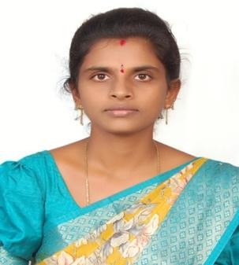
Name of the Faculty : AVULLA RAJINI DEVI
Designation : Assistant Professor
Department : IT
JNTUH Reg.ID : 4655-170119-064811
Date of Birth : 22-05-1992
Date of Joining : 03-01-2025
Memberships : IAENG
Mobile : 9160081785
Mail : avularajinidevi@gmail.com

Academic Qualifications:
S. No. | Degree |  | College/University |  |  |  |  |  | Year of Passing |  | % of Marks
1 | B. Tech |  | JNTU, Hyderabad |  |  |  |  |  | 2013 |  | 78
2 | M. Tech |  | JNTU, Hyderabad |  |  |  |  |  | 2016 |  | 75
Teaching/Industry Experience:
S. No. | Name of the Organization |  |  | Designation |  |  | From |  |  | To |  |  |  | Year &Months
1 | VMTW, Hyderabad |  |  | Assistant Professor |  |  | Jan-2025 |  |  | Till date |  |  |  | 8 months
2 | SCET, Hyderabad |  |  | Assistant Professor |  |  | Mar-2020 |  |  | Jan-2025 |  |  |  | 5years
3 | SCET, Hyderabad |  |  | Assistant Professor |  |  | Dec-2016 |  |  | Dec- 2018 |  |  |  | 2Years
Research Publications:
No. of Papers |  | International |  |  | : | 4 |  | National |  |  |  | : | -
No. of Conference |  | International |  |  | : | 3 |  | National |  |  |  | : | -
No. of Patent |  | International |  |  | : | - |  | National |  |  |  | : | -
No. of Books |  | International |  |  | : | 1 |  | National |  |  |  | : | -
No. of FDPs |  | Attended |  |  | : | 25 |  | Conducted |  |  |  | : | -
No. of Workshops/Seminars |  | Attended |  |  | : | 4 |  | Conducted |  |  |  | : | -
Ratification :Assistant Professor(14.03.2020)

