FACULTY PROFILE
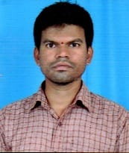
Name : | Mr. K Chandram
Designation: | Assistant Professor
Age : | 34
Joining Date in this Organization: | 01-06-2021
Work Experience in Years :
  Teaching | Industry
  07 | -
Qualification : | M. Tech
Specialization : | Computer Science and Engineering
Phone : | 9948553906
Mail Id : | chandram@vmtw.in

