FACULTY PROFILE
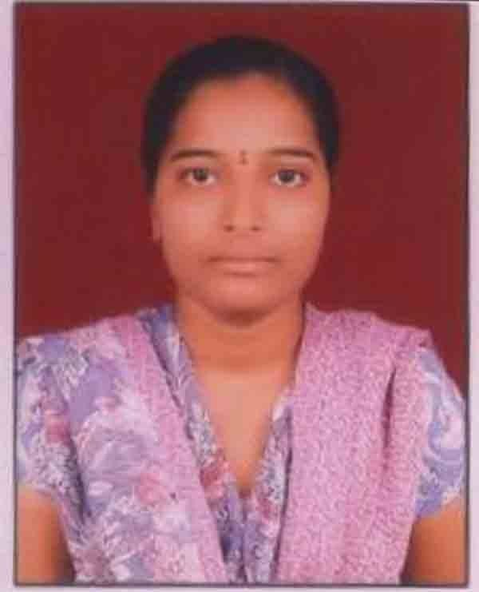
Name : | Mrs. A Enaja
Designation: | Assistant Professor
Age : | 34
Joining Date in this Organization: | 28-02-2022
Work Experience in Years :
  Teaching | Industry
  07 | -
Qualification : | M. Tech
Specialization : | Computer Science and Engineering
Phone : | 9700383819
Mail Id : | enaja@vmtw.in

