FACULTY PROFILE
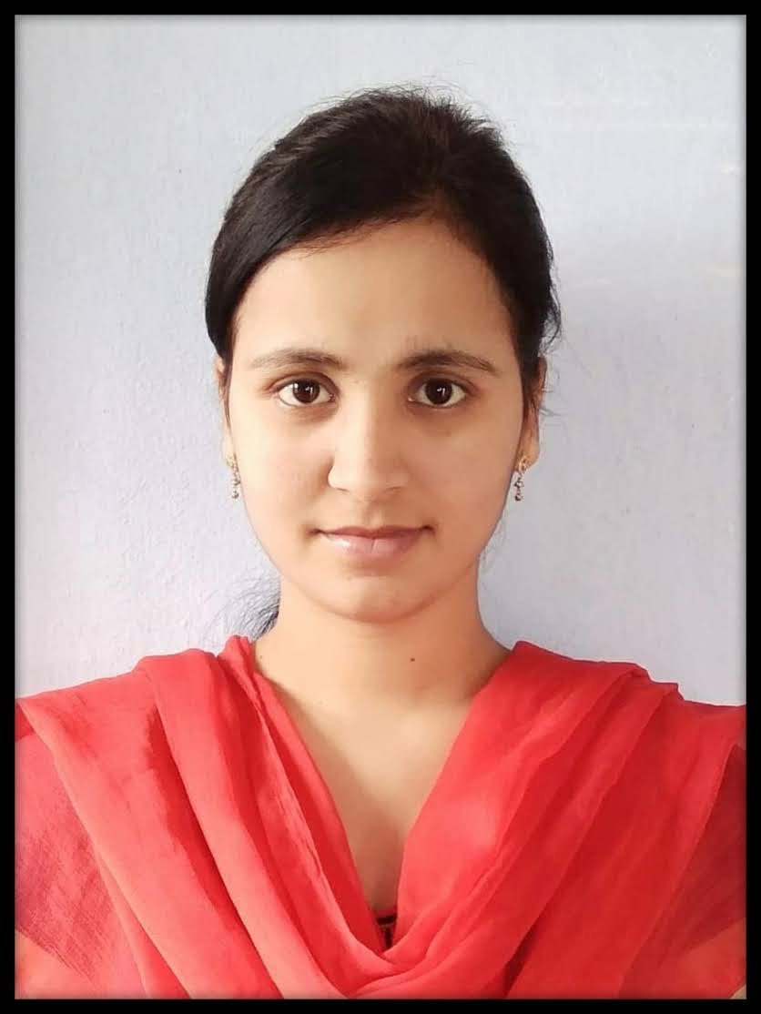
Name : | Ms. Md Fouzia
Designation: | Assistant Professor
Age : | 27
Joining Date in this Organization: | 02-03-2022
Work Experience in Years :
  Teaching | Industry
  05 | -
Qualification : | M. Tech
Specialization : | Computer Science and Engineering
Phone : | 7675917908
Mail Id : | fouzia@vmtw.in

