FACULTY PROFILE
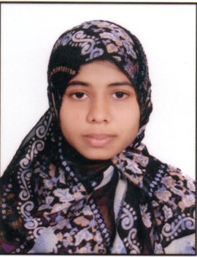
Name : | Ms. Samreen Begam
Designation: | Assistant Professor
Age : | 23
Joining Date in this Organization: | 17-09-2021
Work Experience in Years :
  Teaching | Industry
  01 | -
Qualification : | M. Tech
Specialization : | Computer Science and Engineering
Phone : | 9398205021
Mail Id : | samreen@vmtw.in

