FACULTY PROFILE
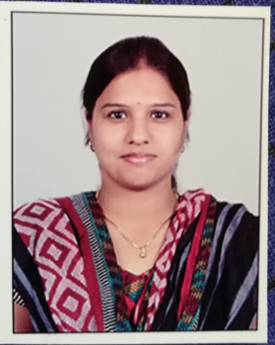
Name : | Mrs. M Sravani
Designation: | Assistant Professor& HOD
Age : | 35
Joining Date in this Organization: | 21-09-2021
Work Experience in Years :
  Teaching | Industry
  10 | -
Qualification : | M. Tech
Specialization : | Computer Science and Engineering
Phone : | 8978960906
Mail Id : | sravani@vmtw.in

