FACULTY PROFILE
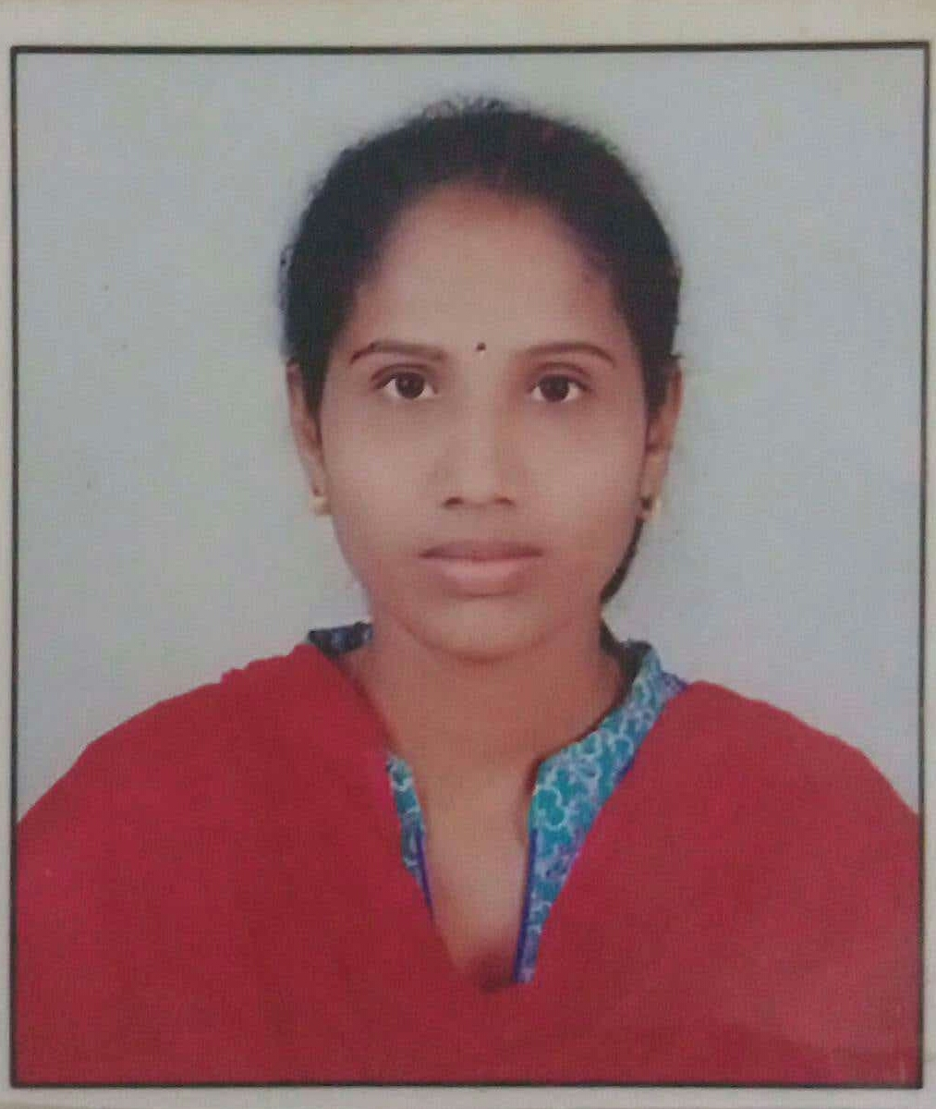
Passport Size Latest Photo

Name : | Mr. N. Sreeja
Designation: | Asst. Prof.
Age : | 32
Joining Date in this Organization: | 16-05-2022
Work Experience in Years :
  Teaching | Industry
  5
Qualification : | M.Tech
Specialization : | Computer Science and Engineering
Phone : | 9398725761
Mail Id : | Nallasreeja61@gmail.com

