FACULTY PROFILE
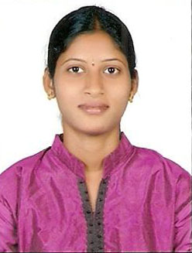
Name : | Ms. Uma Devi Manchala
Designation: | Assistant Professor
Age : | 32
Joining Date in this Organization: | 29-04-2022
Work Experience in Years :
  Teaching | Industry
  7 | --
Qualification : | B. Tech (CSE); M. Tech (CSE)
Specialization : | Computer Science and Engineering
Phone : | 8978787107
Mail Id : | umadevi.manchala92@gmail.com

