FACULTY PROFILE

Name of the Faculty |  |  | : | Dr. S. Ranga Swamy |  |  |  |  |  |  |  |  |  |  |  | 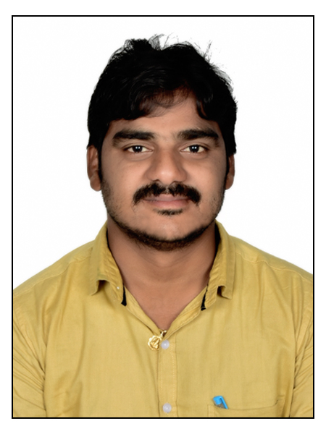
Designation |  |  | : | Associate Professor & HOD
Department |  |  | : | CSE(AI&ML)
JNTUH Reg. ID |  |  | : | 1287-190828-111638
Date of Birth |  |  | : | 29-05-1984
Date of Joining |  |  | : | 23-08-2019
Memberships |  |  | : | LM-ISTE,LM-IEI, IAENG, SDIWC
Mobile |  |  | : | 9989896548, 7013369110 |  |  |  |  |  |  |  | Mail |  | : | sirisatiranga@vmtw.in
Academic Qualifications:
S.No. | Degree |  |  |  | College/University |  |  |  |  |  | Year of Passing |  |  |  |  |  | % of Marks
1 | MCA |  |  |  | SV University |  |  |  |  |  | 2009 |  |  |  |  |  | 65.9
2 | M.Tech |  |  |  | JNTU Anantapur |  |  |  |  |  | 2012 |  |  |  |  |  | 76.8
3 | Ph.D |  |  |  | Nagarjuna University |  |  |  |  |  | 2019 |  |  |  |  |  | -
Teaching/Industry Experience:
S.No. | Name of the Organization |  |  |  |  |  | Designation |  | From |  |  |  | To |  |  |  | Year & Months
1 | VMTW, Hyderabad |  |  |  |  |  | Associate Professor |  | 2019 |  |  |  | till date |  |  |  | 3 Year 10 Months
2 | SVIET, Pedana |  |  |  |  |  | Assistant Professor |  | 2017 |  |  |  | 2019 |  |  |  | 2 Year 3 Months
3 | RNEC, Ongole |  |  |  |  |  | Associate Professor |  | 2012 |  |  |  | 2017 |  |  |  | 4 Year 6 Months
Research Publications:
No. of Papers |  | International |  |  |  | : |  | 26 |  | National |  |  |  |  |  |  |  | : | 0
No. of Conference |  | International |  |  |  | : |  | 11 |  | National |  |  |  |  |  |  |  | : | 0
No. of Patent |  | International |  |  |  | : |  | 01 |  | National |  |  |  |  |  |  |  | : | 10
No. of Books |  | International |  |  |  | : |  | 01 |  | National |  |  |  |  |  |  |  | : | 02
No. of FDPs |  | Attended |  |  |  | : |  | 09 |  | Conducted |  |  |  |  |  |  |  | : | 08
No. of Workshops/Seminars |  | Attended |  |  |  | : |  | 06 |  | Conducted |  |  |  |  |  |  |  | : | 05
Ratification: Assistant Professor(13.12.2019)

