FACULTY PROFILE

Name of the Faculty |  |  | : | A.Eenaja |  |  |  |  |  |  |  |  |  |  |  | 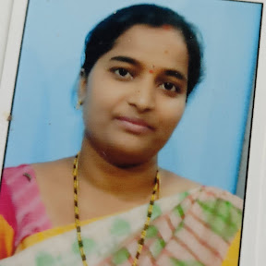
Designation |  |  | : | Assistant Professor
Department |  |  | : | IT
JNTUH Reg. ID |  |  | : | 9159-200306-152110
Date of Birth |  |  | : | 29-03-1989
Date of Joining |  |  | : | 28-02-2022
Memberships |  |  | : | IAENG
Mobile |  |  | : | 9700383819 |  |  |  |  |  |  |  | Mail |  | : | Eenajareddy979@gmail.com
Academic Qualifications:
S.No. | Degree |  |  |  | College/University |  |  |  |  |  | Year of Passing |  |  |  |  |  | % of Marks
1 | M. Tech |  |  |  | JNTUH |  |  |  |  |  | 2014 |  |  |  |  |  | 81
2 | B. Tech |  |  |  | JNTUH |  |  |  |  |  | 2010 |  |  |  |  |  | 61
3 | S.S.C |  |  |  | SSC |  |  |  |  |  | 2004 |  |  |  |  |  | 86
Teaching/Industry Experience:
S.No. | Name of the Organization |  |  |  |  |  | Designation |  | From |  |  |  | To |  |  |  | Year & Months
1 | VMTW, Hyderabad |  |  |  |  |  | Assistant Professor |  | 2022 |  |  |  | till date |  |  |  | 1.6 Years
2 | Holy Mary Institute of Science and  Technology |  |  |  |  |  | Assistant Professor |  | 2020 |  |  |  | 2021 |  |  |  | 2 Years
3 | GLOBAL Group of  Institutions |  |  |  |  |  | Assistant Professor |  | 2014 |  |  |  | 2017 |  |  |  | 3 Years
Research Publications:
No. of Papers |  | International |  |  |  | : |  | 4 |  | National |  |  |  |  |  |  |  | : | 0
No. of Conference |  | International |  |  |  | : |  |  |  | National |  |  |  |  |  |  |  | : | 0
No. of Patent |  | International |  |  |  | : |  | - |  | National |  |  |  |  |  |  |  | : | 2
No. of Books |  | International |  |  |  | : |  | - |  | National |  |  |  |  |  |  |  | : | 1
No. of FDPs |  | Attended |  |  |  | : |  | 20 |  | Conducted |  |  |  |  |  |  |  | : | -
No. of Workshops/Seminars |  | Attended |  |  |  | : |  | 10 |  | Conducted |  |  |  |  |  |  |  | : | -
Ratification: Assistant Professor(25.05.2017)

